Vectors for yeast Saccharomyces cerevisiae
Yeast S. cerevisiae has a genome of approximately 2 X 10⁷ base pairs contained in 16 linear chromosomes and some strains possess a type of plasmid known as the 2-micron circle. This 6 kb plasmid is present in a copy number of between 70 and 200 copies per cell.
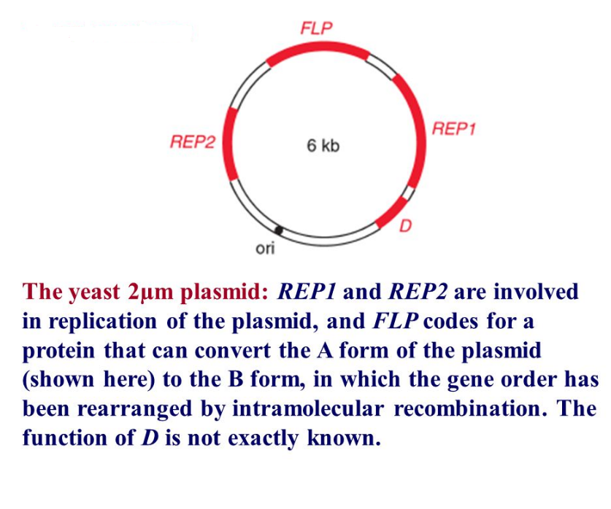
Yeast selectable markers
Unlike the dominant antibiotic resistance markers used in E. coli. transformations, yeast selectable markers are genes which compliment specific auxotrophy (e.g. Leu-, His-, Trp- etc.) and does require the host cell to contain a recessive, known reverting mutation.The most commonly used auxotrophic selection markers for the selection of transformants are LEU2, TRP1, URA3, and HIS3 used in corresponding mutant strains which are auxotrophic for leucine tryptophan uracil and histidine respectively.
Auxotrophy is the inability of an organism to synthesize a particular organic compound required for its growth. The host must be an auxotrophic mutant that has a non-functional gene for the corresponding selectable marker gene. Selection is possible because transformants contain a plasmid-borne functional copy of the host mutant gene.

Yeast episomal plasmids (YEp)
Yep vectors are based on the endogenous yeast 2µm plasmid which contains genetic information for its own replication and segregation. Some YEps contain contain the entire 2µ plasmid, others include eonly origin of replication of the 2µ plasmid and backbone of a E. coli vector such as pBR322, pUC19 (Example. Yep13). They are capable of autonomous relication and are present at 20-200 copies per cell. They contain yeast selection marker such URA3, HIS3, TRP1, LEU2.
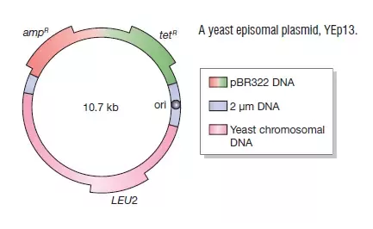
The word ‘episomal’ indicates that a YEp can replicate as an independent plasmid, but also implies that the integration into one of the east chromosomes can occur. Integration occurs because the gene carried on the vector as a selectable marker is very similar to the mutant version of the gene present in the yeast chromosomal DNA .With YEp13 for example homologous recombination can occur between the plasmid and LEU2 gene and the yeast mutant LEU2 gene resulting in insertion of the entire plasmid into one of the yeast chromosomes the plasmid may remain integrated or a later recombination event may result in it being excised again.

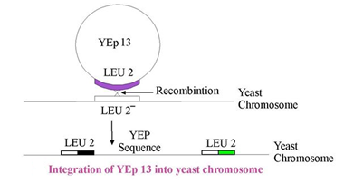

Yeast integrative plasmids (YIp)
Theese are basically bacterial plasmids carrying a yeast gene. An example is YIp5, which is pBR322 with an inserted URA3 gene. This gene encodes for orotidine-5’- phosphate decarboxylase (an enzyme that catalyzes on of the steps in the biosynthesis of pyrimidine nucleotides) and is used as a selectable marker. A YIp cannot replicate independently as it does not contain any parts of the 2µm plasmid, and instead depends for its survival on integration into yeast chromosomal DNA. YIp integrate by recombination between homologous sequences on the YIp plasmid and the host genome.They are normally present at one copy per cell and are very stable.
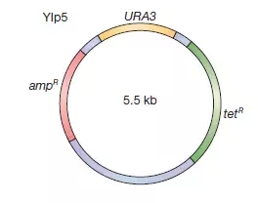
Yeast centromeric plasmids (YCp)
These vectors contain an autonomous replicating sequence (ARS) of chromosomal origin and a yeast centromere. The ARS can be either chromosomal or 2µm in origin. YCps are normally present at one copy per cell. They can replicate without integration into a chromosome and are stably maintained during cell division.
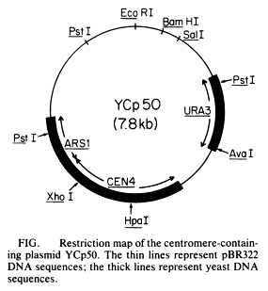
References
- Life Sciences by Pranav Kumar and Usha Mina Pathfinder publication.
- Gene coning and DNA analysis by T.A. Brown

